**Output of the Program in Eclipse Console**

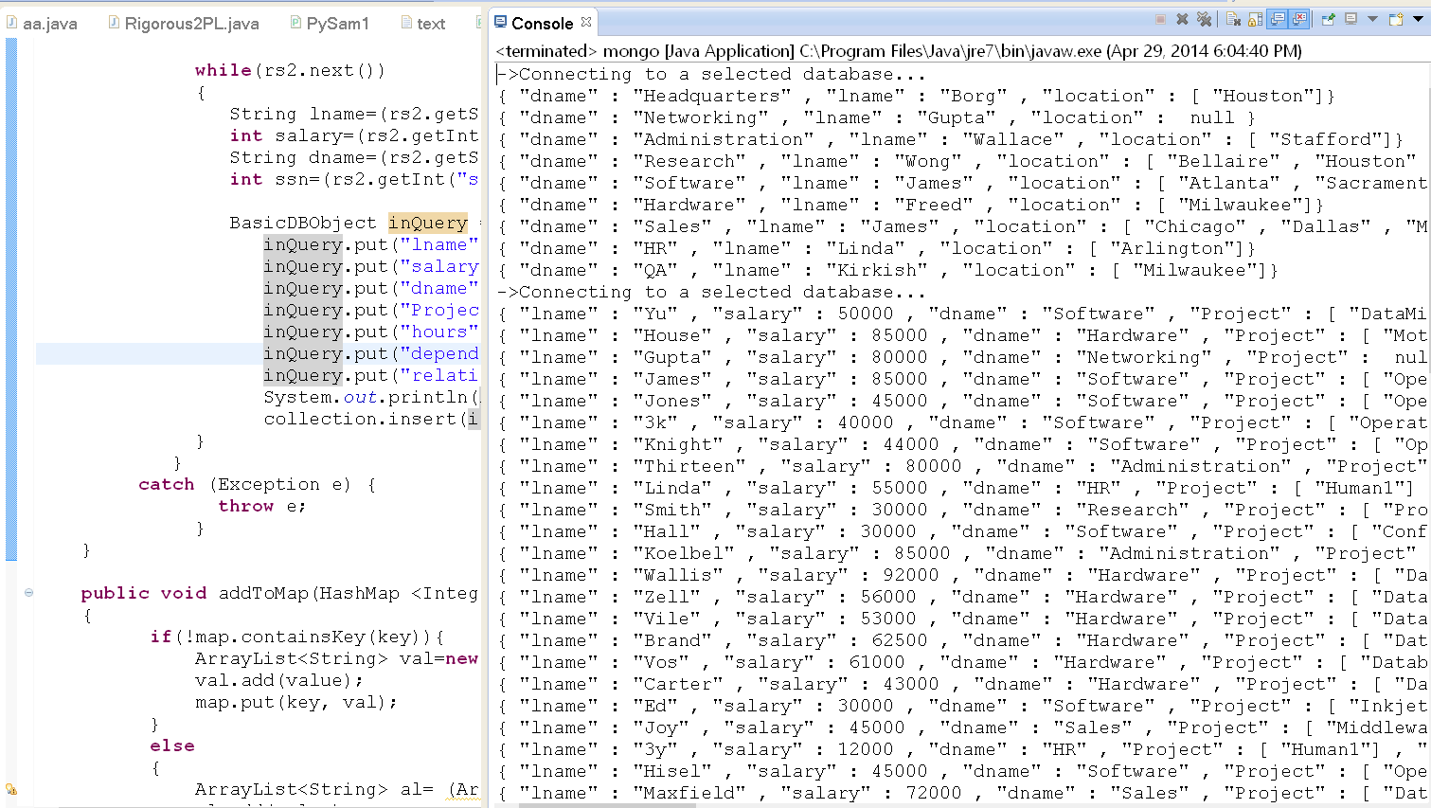

**Queries:**

**1. List all employees (Lname) who have at least $75,000 salary.**

db.employee.find({salary:{$gte:75000}},{lname:1})

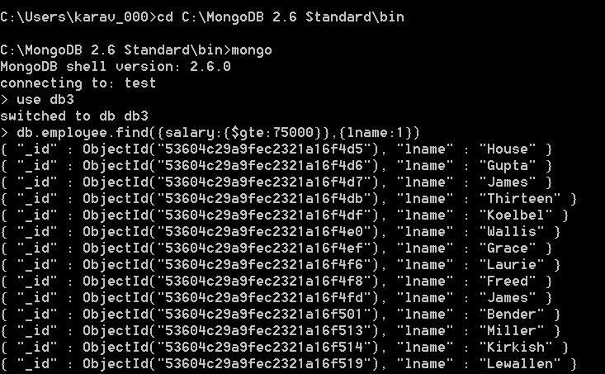

**2. List all employees (Lname) who work in the department whose name is “Research”.**

db.employee.find({dname:’Research’},{lname:1})

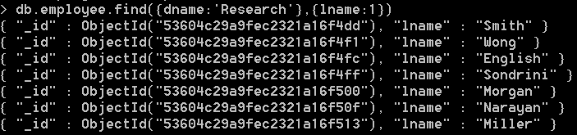

**3. List all employees (Lname) who work in the department whose name is “Research” and have at least $75,000 salary.**

db.employee.find({$and:[{dname:’Research’},{salary:{$gte:75000}}]},{lname:1})



**4. List the manager (Lname) for the department whose name is “Research” or “Software”.**

db.department.find({$or:[{dname:’Research’},{dname:’Software’}]},{lname:1})



**5. List all employees (Lname) who work on “ProductX” project.**

db.employee.find({Project:’ProductX’},{lname:1})

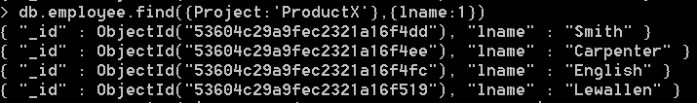

**6. List all employees (Lname) who work on “ProductX” project for at least 20 hours.**

db.employee.find({$and:[{Project:’ProductX’},{hours:{$gte:20}}]},{lname:1})

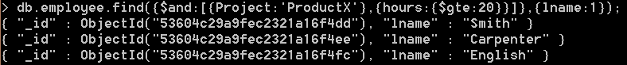

**7. List all departments (Dname) which have a location in Dallas.**

db.department.find({location:’Dallas’},{dname:1})



**8. List all dependents (Dependent_name) of employee “Franklin Wong”.**

db.employee.find({lname:’Wong’},{dependent_name:1})

